|  |  |
| --- | --- |
| https://lh3.googleusercontent.com/Z_Ko1p8TxXK4UsOZLy-P5Q70cUJAwuoJFHM-y_C2roSTwbPkAXANe93NypeZgoz-j077saBz7EUq28Rv6hSNNMXTwFpm9p9khB037e5LCOHL87o55tt756tcoEqHxVnIsQfDG4g | **FPT ACADEMY INTERNATIONAL FPT – APTECH COMPUTER EDUCATION** |

**Centre Name: ACE-HCMC-2-FPT.**

**Address: 590 Cach Mang Thang 8, District 3, Ho Chi Minh City, Viet Nam.**

**Liberty Electronics**

|  |  |  |
| --- | --- | --- |
| **Supervisor:** | Phạm Thị Lánh | |
| **Batch No:** | T1.2112.E0 | |
| **Term:** | 1 | |
| **Group No:** | Group 2 | |
| **Order:** | **Full name** | **Roll No.** |
| 01. | Trần Văn Thịnh | Student1352179 |
| 02. | Lê Văn Hùng | Student1352174 |

April 2022

This is to certify that

**Mr. TRẦN VĂN THỊNH**

**Mr. LÊ VĂN HÙNG**

Have successfully Designed & Developed

**CERAPHY**

Submitted by:

**Ms. PHAM THI LANH**

Date Of Issue:

Authorized Signature:



**Content**

Contents

Acknowledge 4

Synposis 5

Problem Definition 6

SiteMap 10

Screen shots 11

I. Homepage: 11

II. Description: 12

III. About: 13

IV. Product: 14

4.1 Hover Product 14

4.2 Product For Children 15

4.3 Product For Adult 16

V. Contact: 17

17



**Acknowledge**

We know that E_Project is a step-by-step environment file

closely simulate the learning environment based on a small project in your hand

It allows you to:

- Take steps to complete a project.

- Build a powerful application.

- Use useful tools in user-designed applications.

- Unified program to create a complete application.

Learn to implement concepts in stages.

- Improve skills and add value.

- Work on real projects.

- Give a realistic scenario and help create more diverse sets of applications and

useful.

We would like to extend a big thank you to our professors and members who contributed significantly during their time on the project.

Besides the server errors we had to answer in the project, we hope there will be many opportunities to expand our understanding in the world of web development.

Since then, we have gained more experience from this project, we will never stop learning anything to be more successful in the future.

your sincerely,

Group team 02



**Synopsis**

The goal of the program that we want to achieve is to launch a project to provide fonts to users. This application helps people to better know what Font has to offer.

-It's not about teaching us HTML/JavaScript but giving us a real scenario and helping us create basic apps using the tools.

-The goal is not to teach you about software but to give you real life and help you create basic apps with tools.

-You are free to choose topics within the framework of the project before starting.

-This project is for students who have completed the module of HTML5.

These programs should be implemented within the time specified by the school with faculty support if required.

-The website (in this project) is a place to learn more about knowledge.

-It is suitable for many ages.(adults, children,…).

It is very important that students understand the subject well.



**Problem Definition**

=

# Problem Definition

Caraphy is a company which provides artistic fonts as products. Our company has been established for 2 years and has achieved a lot of successful. We produce customised letters, invitations, and so on.

Caraphy products have become so popular that the demand for the products from the local market has increased.

The website is to be developed for the Windows Platform using HTML5, JavaScript and Geolocation. The site should work well in all leading browsers including Chrome, IE, Firefox etc.

And here are some problems need to be solved:

Due to the innovation of the product, customers have a lot of questions that need to be answered. And the website has to informative enough to answer all the questions.

The user will have difficulty in using the website because not many companies are doing this kind of website, and so there will be a couple of problems during the using experience.

And to help the customers have the best experience in using the website, or when the customers need help, support from our company, the website needs to have a form to fill in or a section of comments to fill in case of needs

|  |
| --- |
| USER |
| Input:  -Input consumer’s address of residence or office to receiving the products  -Send questions/requests to the company |
| Process:  -Process consumer’s address data  - Collect questions/requests sent by consumers |
| Output:  - Show the store address to consumers  - Reply to the consumer’s requests/questions. |

|  |
| --- |
| WEBMASTER |
| Input:  - Control website database, input product information,... |
| Process:  - Analyze website |
| Output:  - Website interface, images, forms, ...  - Giving interaction |

|  |
| --- |
| HARDWARE / SOFTWARE REQUIREMENT: |
| Software:  - Notepad/HTML editor  - Dreamweaver/Javascript |

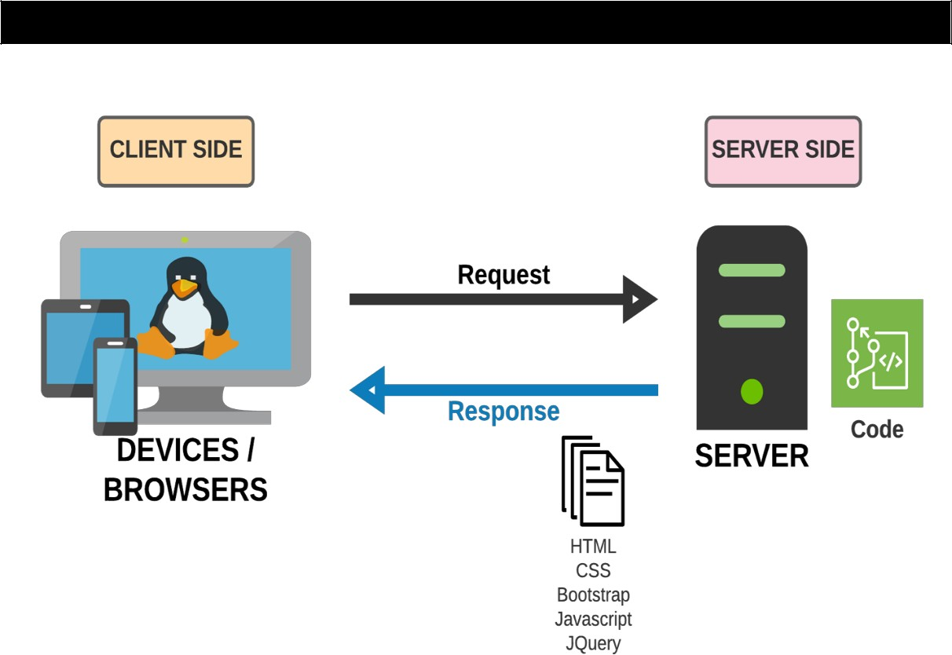

**Architecture and design of the project**



**Site Map**

# Site Map

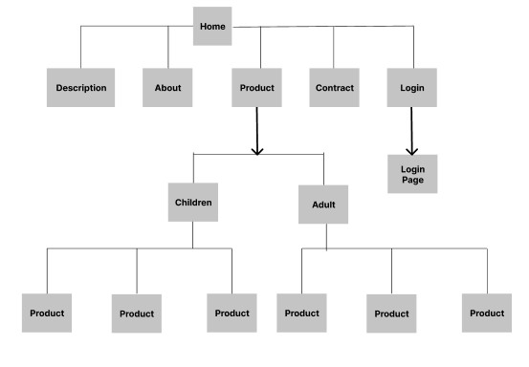



**Screen shots**

# Screen shots

## Homepage:

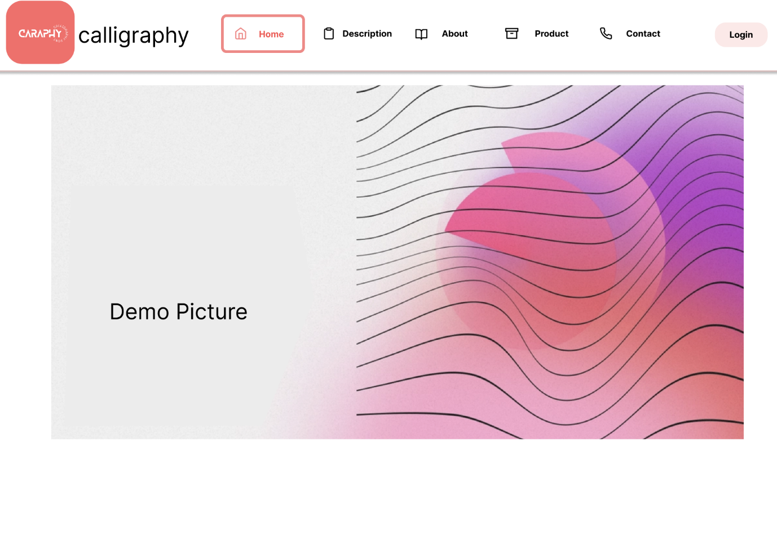

## Description:

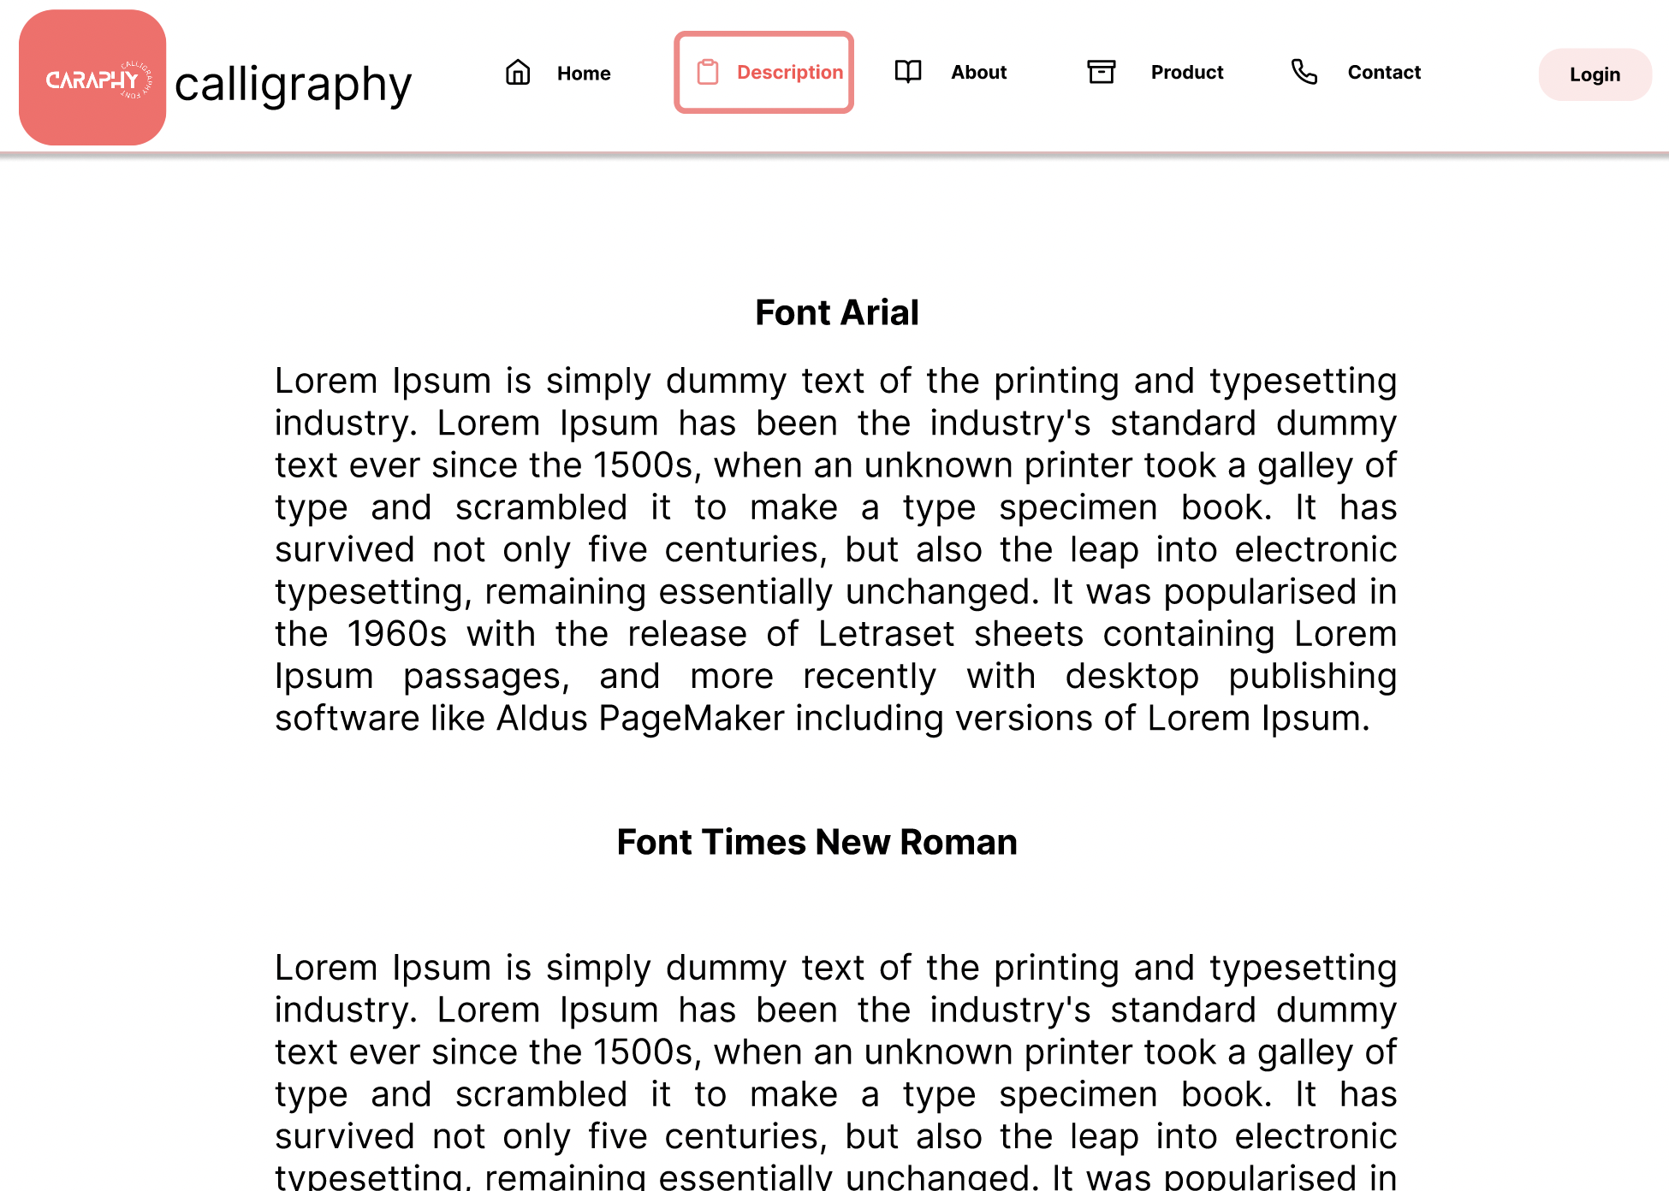

## About:

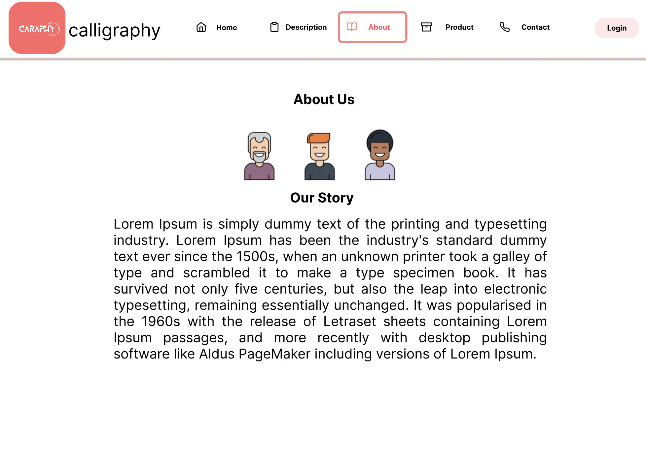

## Product:

### 4.1 Hover Product

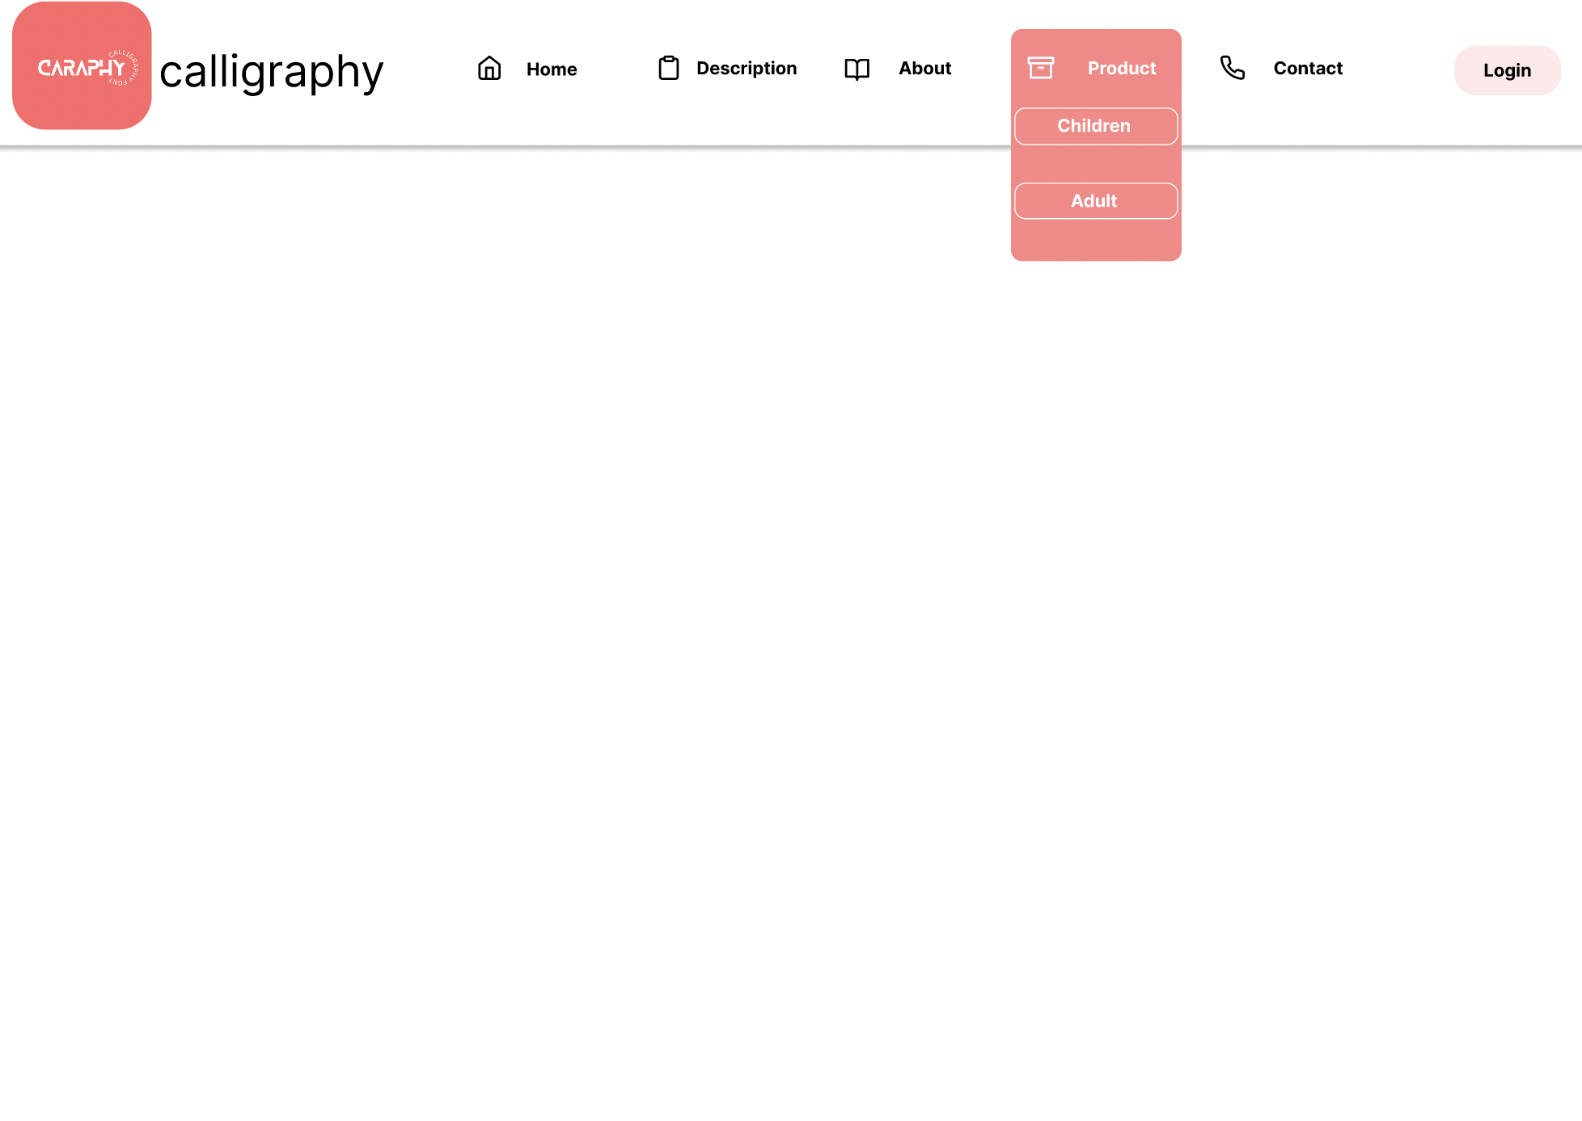

### 4.2 Product For Children

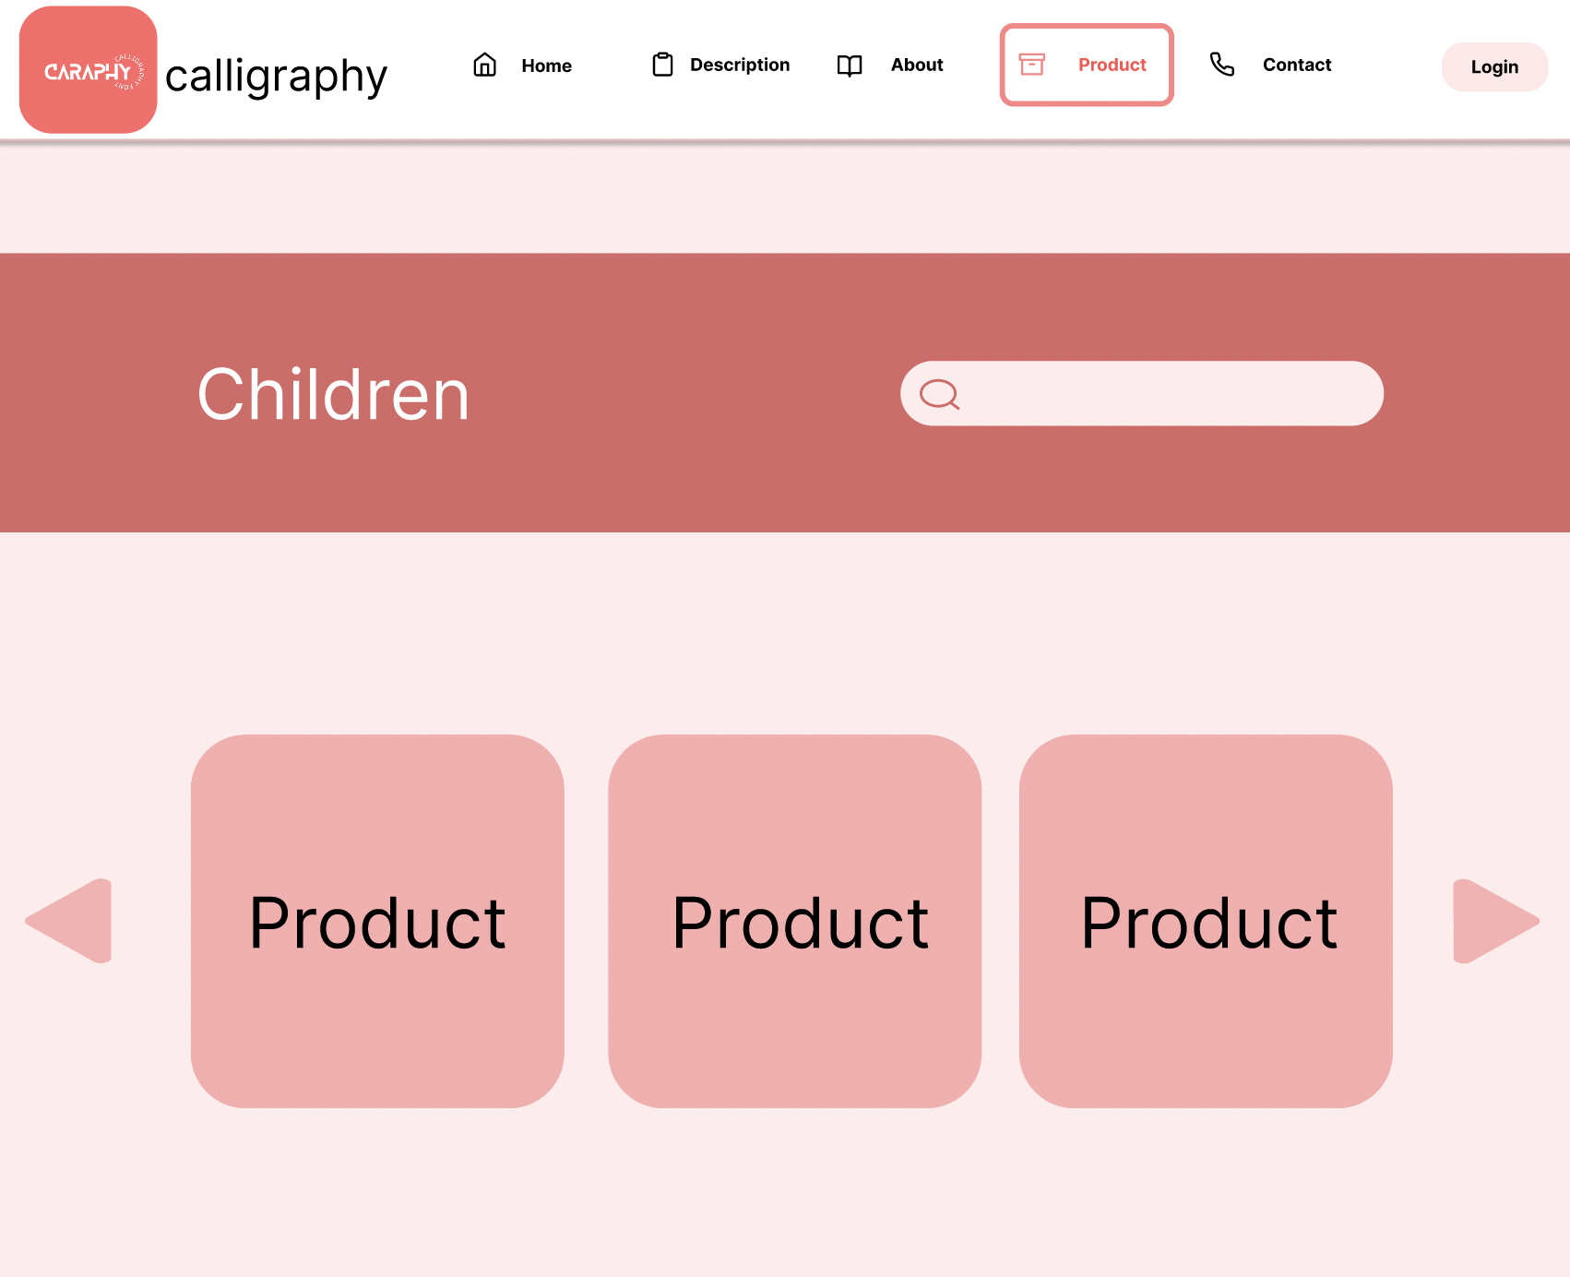

### 4.3 Product For Adult

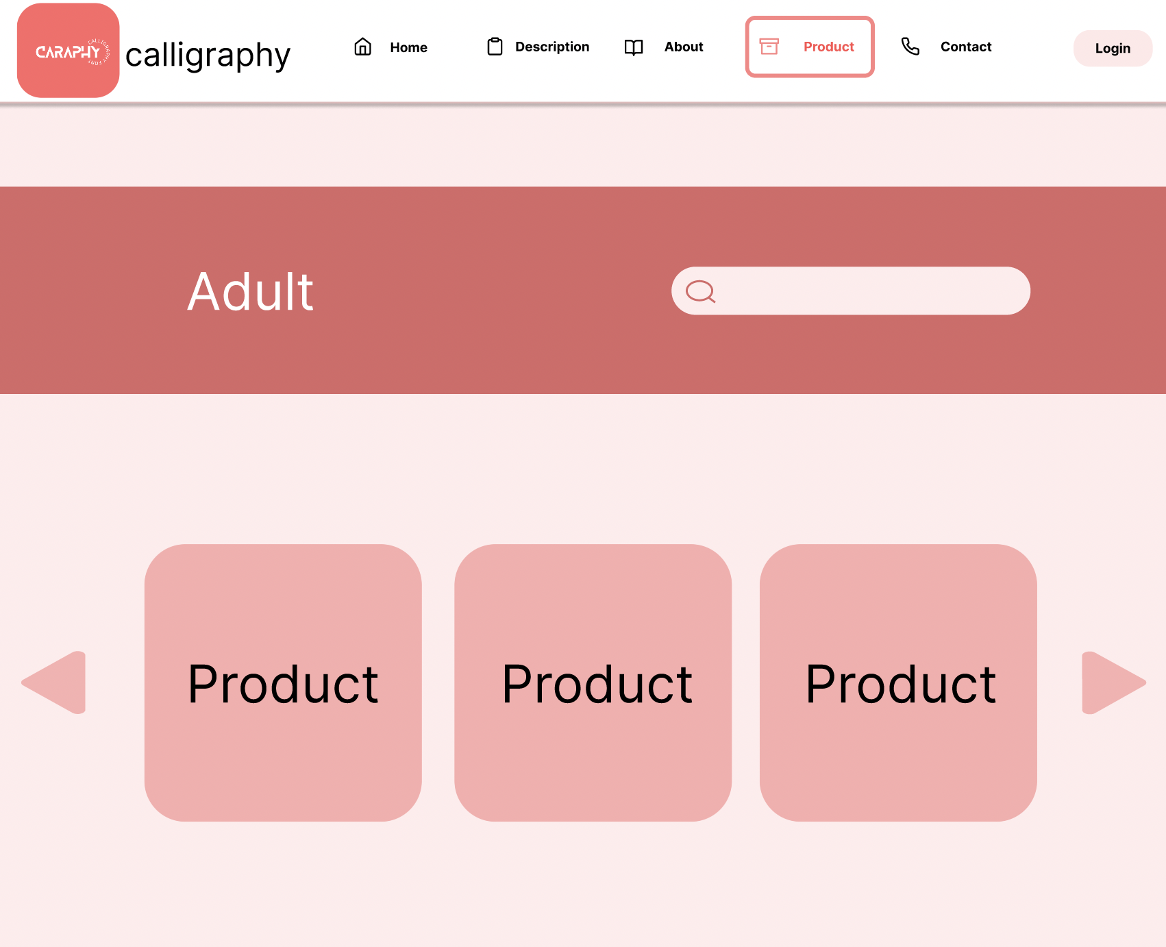

## Contact:

## 

**REVIEW 2**

1. **Homepage**

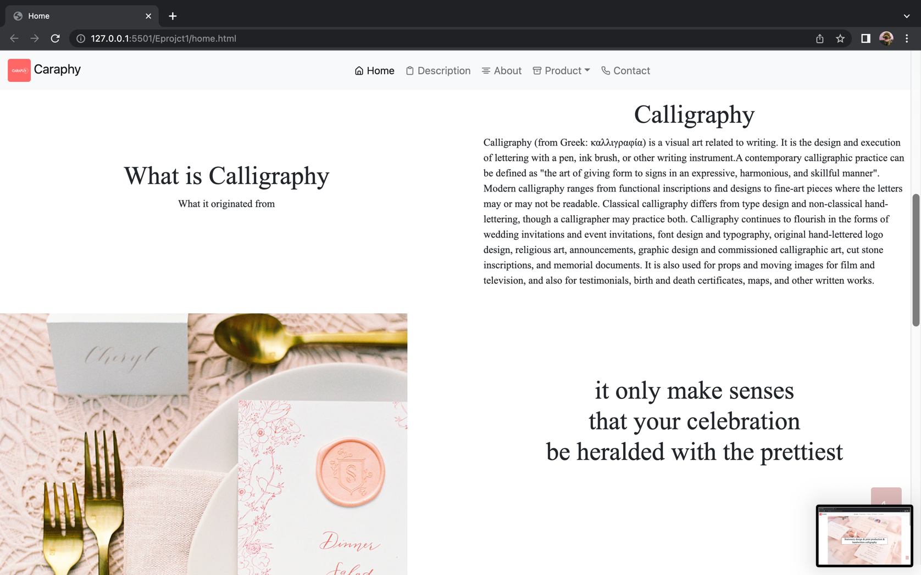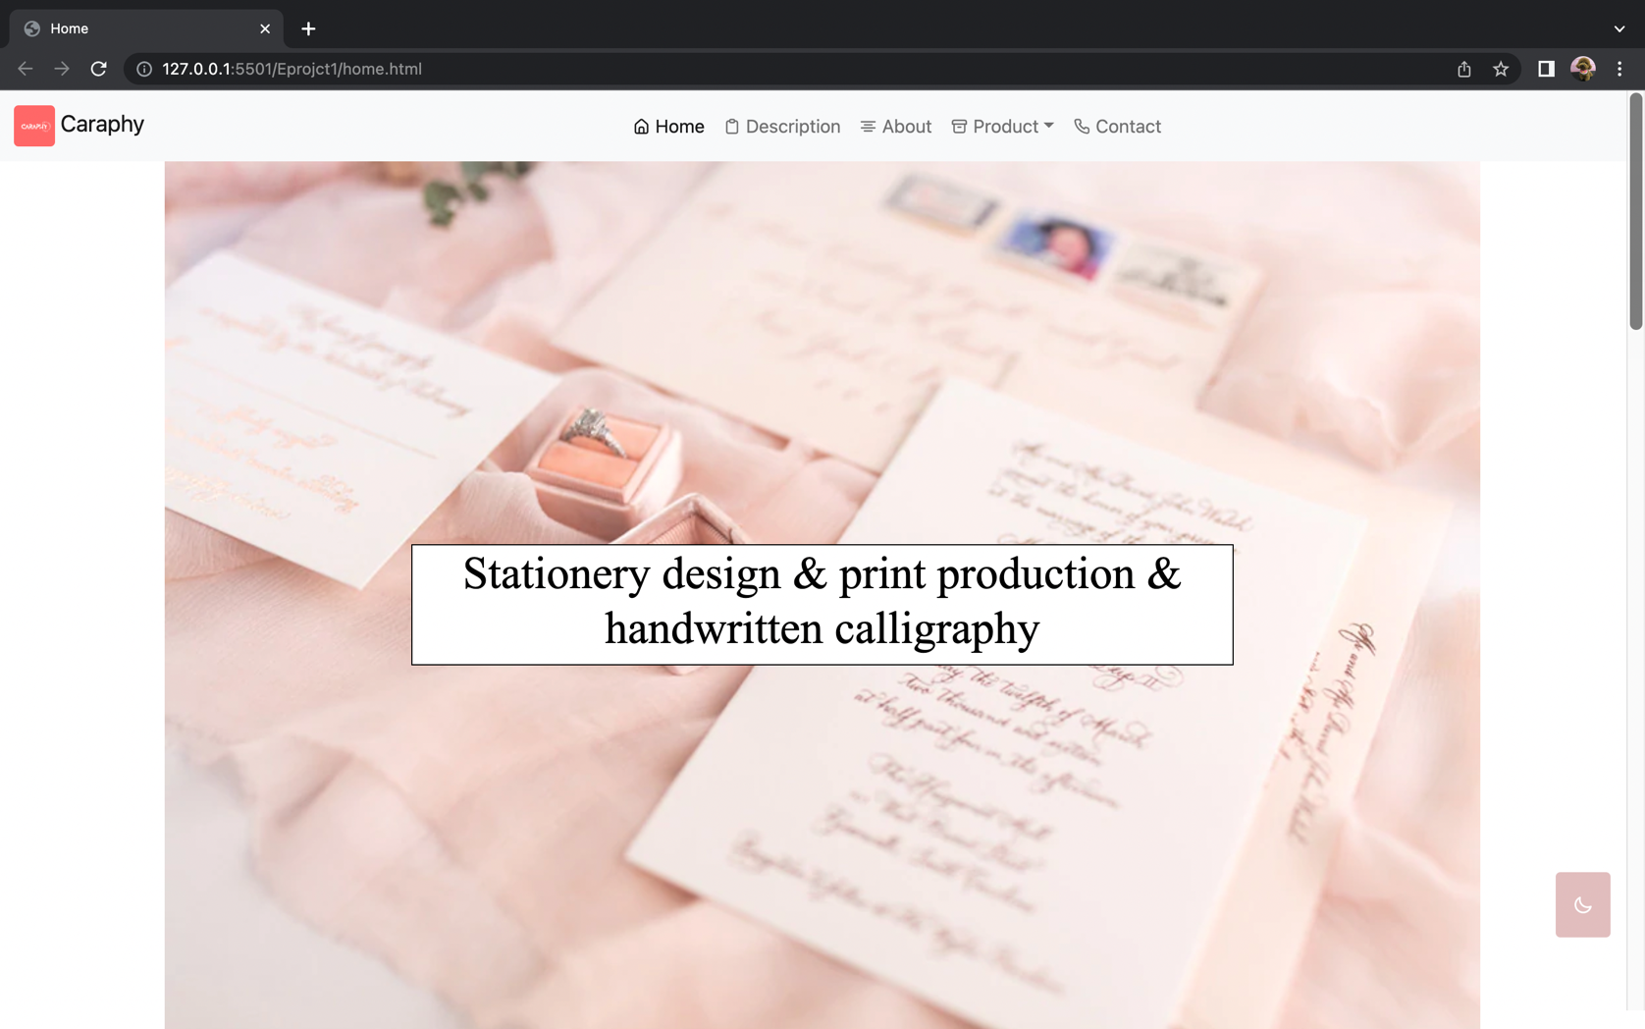

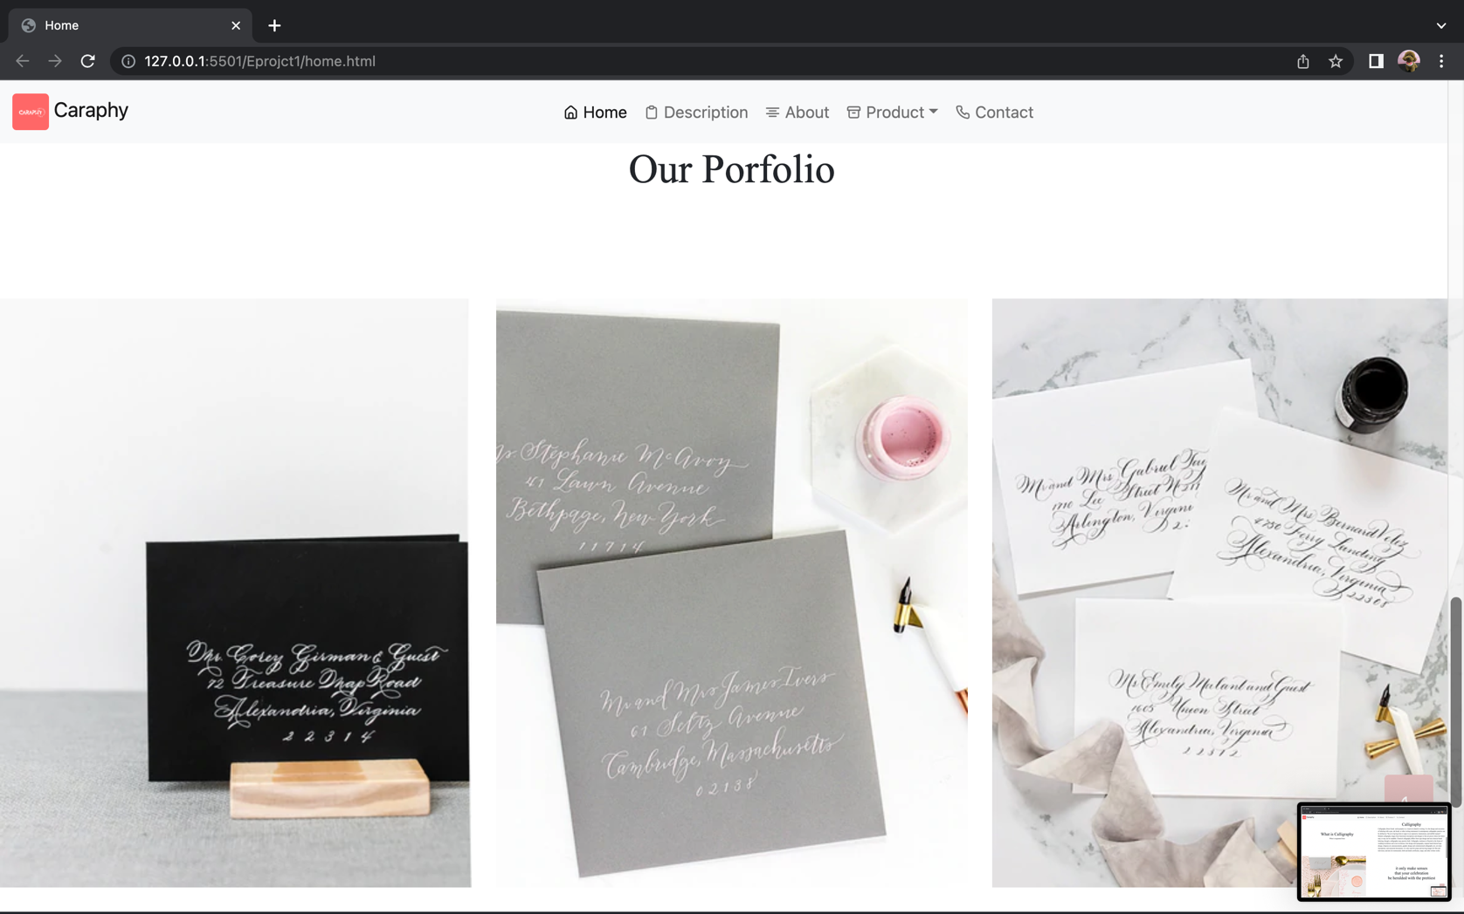

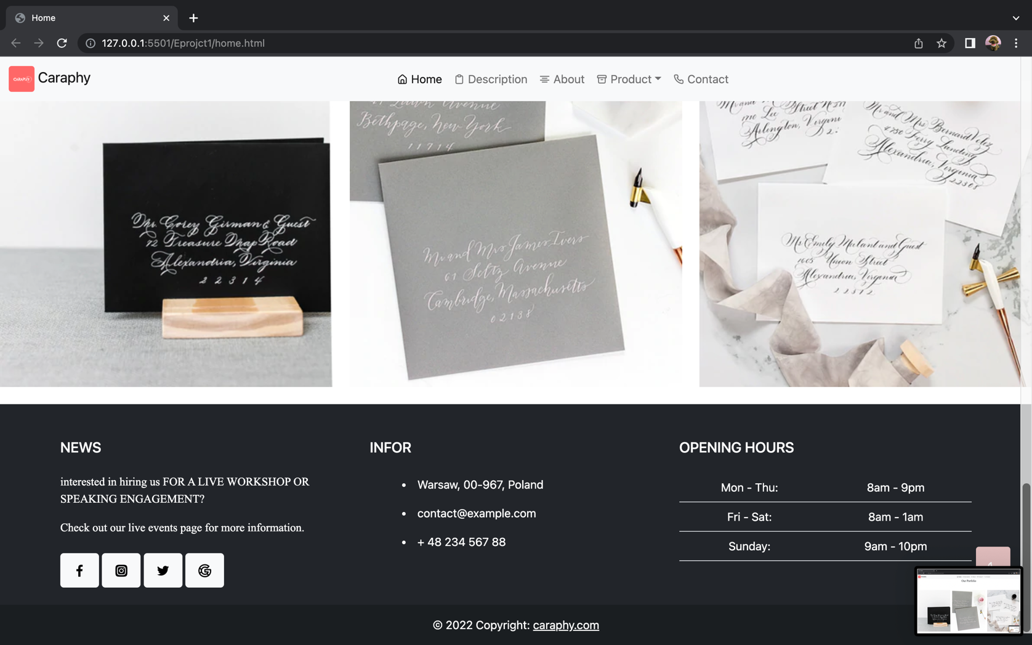

1. 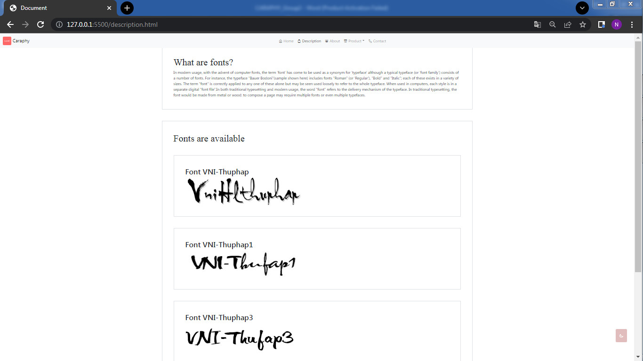**Description:**
2. **About:**

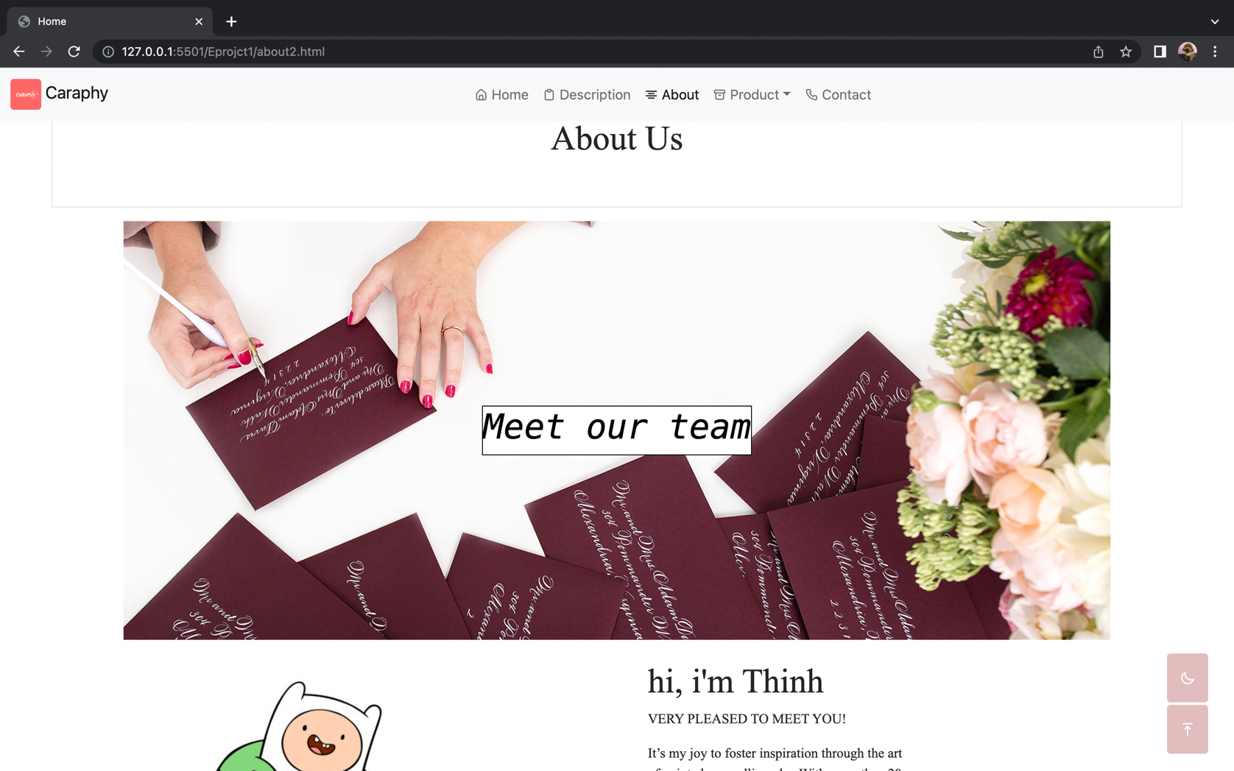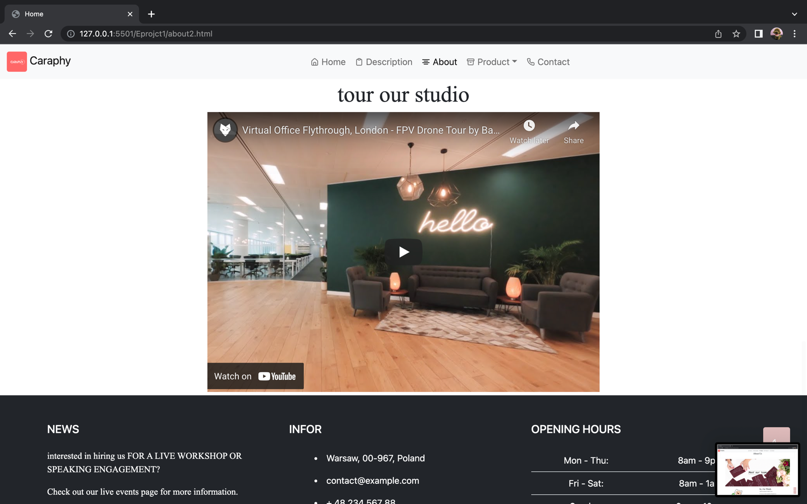

1. **Product:**
2. **Children:**

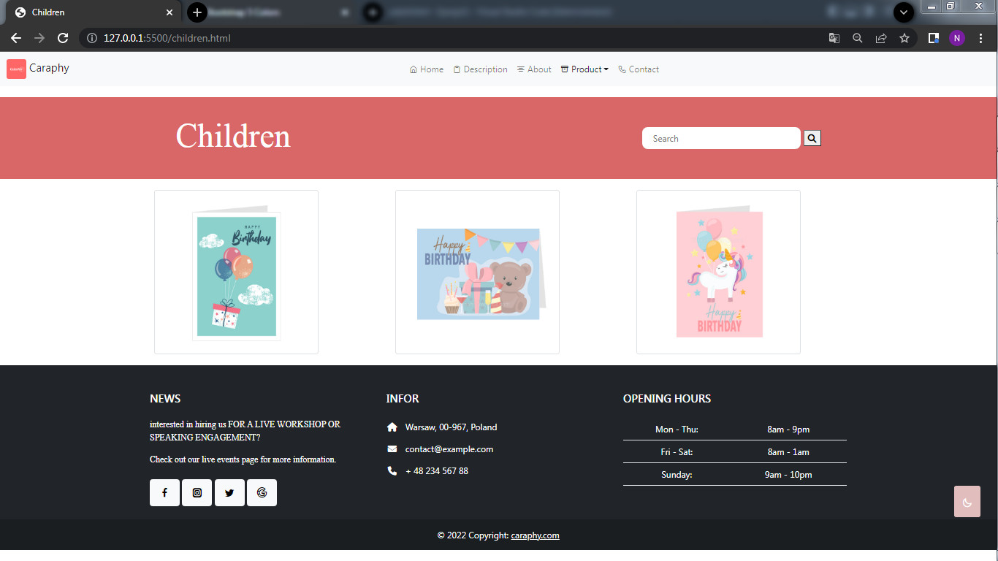

1. **Adult:**

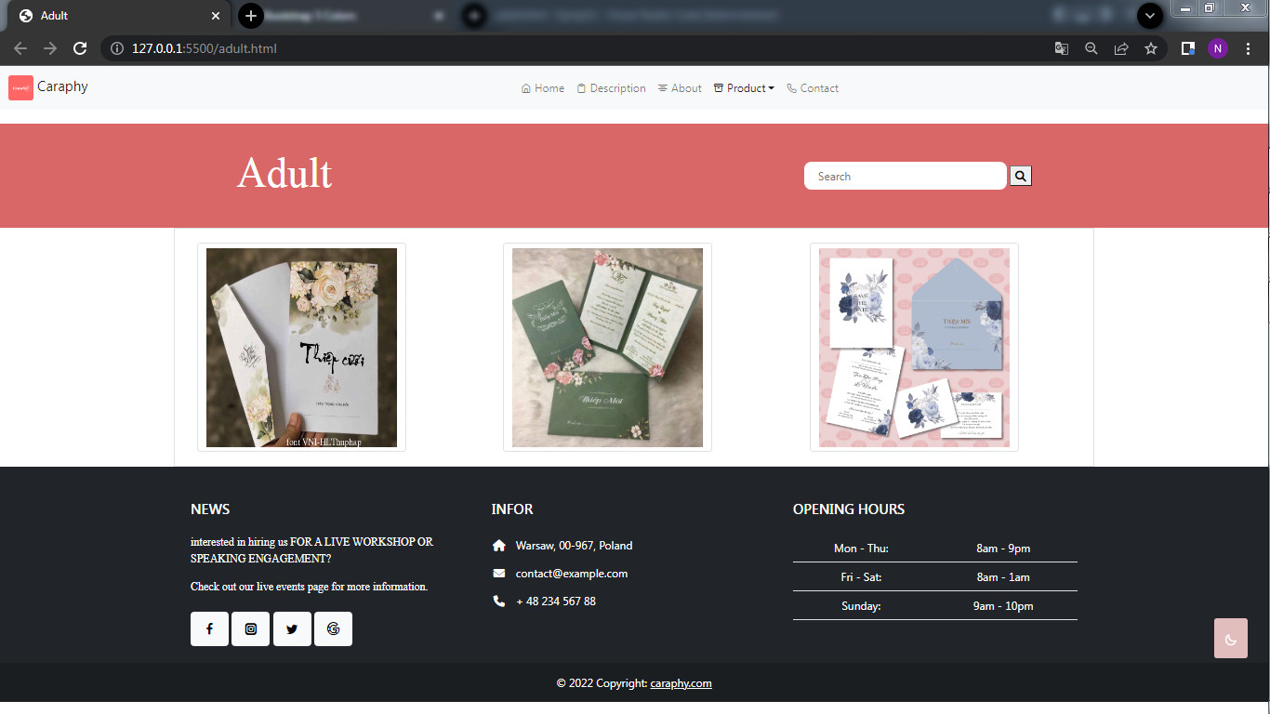

1. **Contact:**

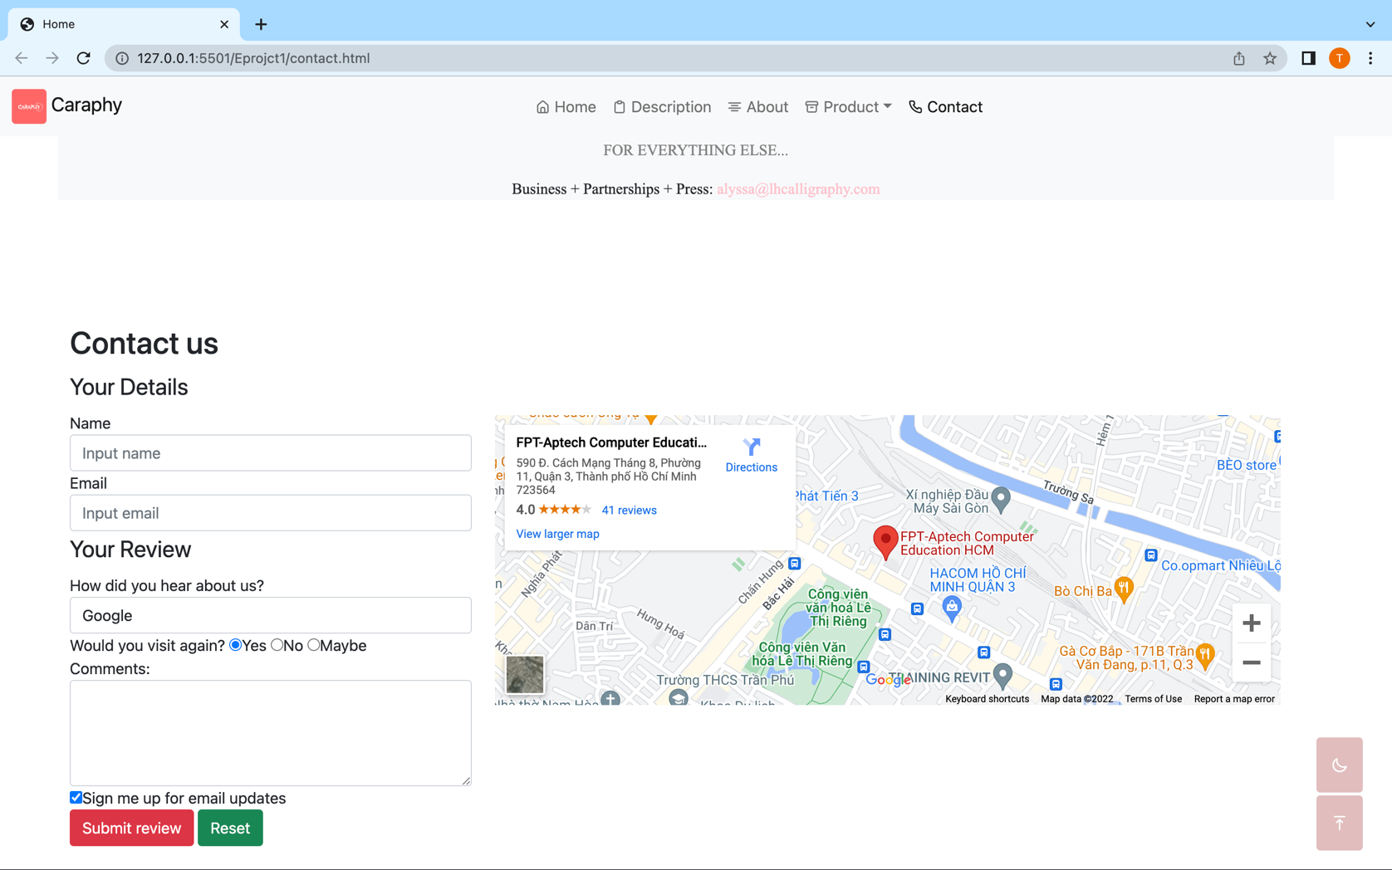

Task Sheet

|  |  |  |  |  |  |  |  |
| --- | --- | --- | --- | --- | --- | --- | --- |
| No. | Project Ref No. | Project  Title – Ask  Me Mobile | Activity  Plan  Prepared  by | Date of preparation of Activity Plan | | | |
| Task | Actual  Start Date | Actual Days | Teammate  Names | Status |
| 1 | Brainstorming ideas for  layouts and Project Object | | Thịnh | 29/03 | 29/03 | Thịnh, Nhân | Done |
| 2 | Draw site maps and  architecture design | | Thịnh, Nhân | 29/03 | 29/03 | Thịnh, Nhân | Done |
| 3 | Wire framing general page layout | | Thịnh, Nhân | 29/03 | 29/03 | Thịnh, Nhân | Done |
| 4 | Collect static assets (pictures,  mp4, documentation,...) | | Thịnh, Nhân | 29/03 | 29/03 | Thịnh, Nhân | Done |
| 5 | Design & Build Home Page | | Thịnh | 06/04 | 06/04 | Thịnh | Done |
| 6 | Design & Build Contact Page | | Thịnh | 08/04 | 08/04 | Thịnh | Done |
| 7 | Design & Build About Us Page | | Thịnh | 09/04 | 09/04 | Nhân | Done |
| 8 | Design & Build Footer Session | | Thịnh | 10/04 | 10/04 | Nhân | Done |
| 9 | Design & Build Description | | Nhân | 13/04 | 13/04 | Nhân | Done |
| 10 | Design & Build Product | | Nhân | 15/04 | 15/04 | Nhân | Done |
| 11 | Write project report | | Thịnh, Nhân | 20/04 | 25/04 | Thịnh, Nhân | Done |

|  |  |  |
| --- | --- | --- |
| Sr.No | Features Tested | Remarks |
| 1 | Are all the users able to view the images and links? | OK |
| 2 | Have all the views, modules and controllers been OK  properly integrated and is the site function as a single  page application? | OK |
| 3 | Are the GUI content devoid of spelling mistakes? | OK |
| 4 | Is the application user-friendly? | OK |
| 5 | Is the Website launching correctly in all popular OK  browsers? | OK |
| 6 | Are all the forms validated with proper criteria? | OK |
| 7 | Are all the forms validated with proper criteria? | OK |
| 8 | Do all image links lead to the appropriate website? | OK |
| 9 | Are all the images and links clearly visible on the page? | OK |
| 10 | Does the Web page work properly in all the tested browsers? | OK |
| 11 | Does the Web page take too long to be loaded fully? | OK |
| 12 | Is the navigation sequences correct through all the Webpages on the site? | OK |
| 13 | Is the JavaScript code working as expected in all click events? | OK |
|  |  |  |
|  |  |  |

Testing Document

Final Checklist

|  |  |  |
| --- | --- | --- |
| Sr.No | Aspected Tested | Suggestion/  Remarks |
| 1 | Are all the users able to view the images and links? | OK |
| 2 | Have all the views, modules and controllers been properly integrated and is the site function as a single  page application? | OK |
| 3 | Are the GUI content devoid of spelling mistakes? | OK |
| 4 | Is the application user-friendly? | OK |
| 5 | Is the Website launching correctly in all popular browsers? | OK |
| 6 | Are all the forms validated with proper criteria? | OK |
| 7 | Do all text links lead to the appropriate website? | OK |
| 8 | Do all image links lead to the appropriate website? | OK |
| 9 | Are all the images and links clearly visible on the page? | OK |
| 10 | Does the Web page work properly in all the tested browsers? | OK |
| 11 | Does the Web page take too long to be loaded fully? | OK |
| 12 | Is the navigation sequences correct through all the Web pages on the site? | OK |
| 13 | Is the JavaScript code working as expected in all click events? | OK |